**CS39930 – Assignment**

**Business Analysis**

**150071107**

**Contents**

Introduction 3

Stakeholders 4

Typical Users 4

Use Cases 6

Related Material 7

# Introduction

The website to be created following completion of this project is that of a dual role. It is a website serving as a recruitment aid for the local Aberystwyth air cadets’ squadron and also an administration area for tracking progress of its members.

The standard area of the website is that of an information aid; it gives as much information as possible in a clean and well understood format to present prospective recruits with as many reasons as possible to join the air cadets. It also provides an easy and effective method of providing communication options through a ‘contact us’ tab. This tab will give all the contact information required such as address, telephone number, email and potentially the inclusion of an automated form.

The other area of the website is an administration area. This area will give the members of staff at the air cadets’ squadron the ability to effectively track the progress of how the cadets are doing in regards to their ‘cadet career’. It also allows the tracking and management of ‘leaves of absence’ to determine who will not attend a normal night as opposed to using facebook as a tracking mechanism.

Overall, this website is here as both a tool to recruit more cadets and so that the cadets’ progress can be tracked more effectively; improving the quality of everything going on for them there. The client themselves is one intertwined with myself – I am a member of staff at the local air cadets squadron itself. However, I am creating it for the staff team there with the main recommendations and communication being through the officer commanding there.

# Stakeholders

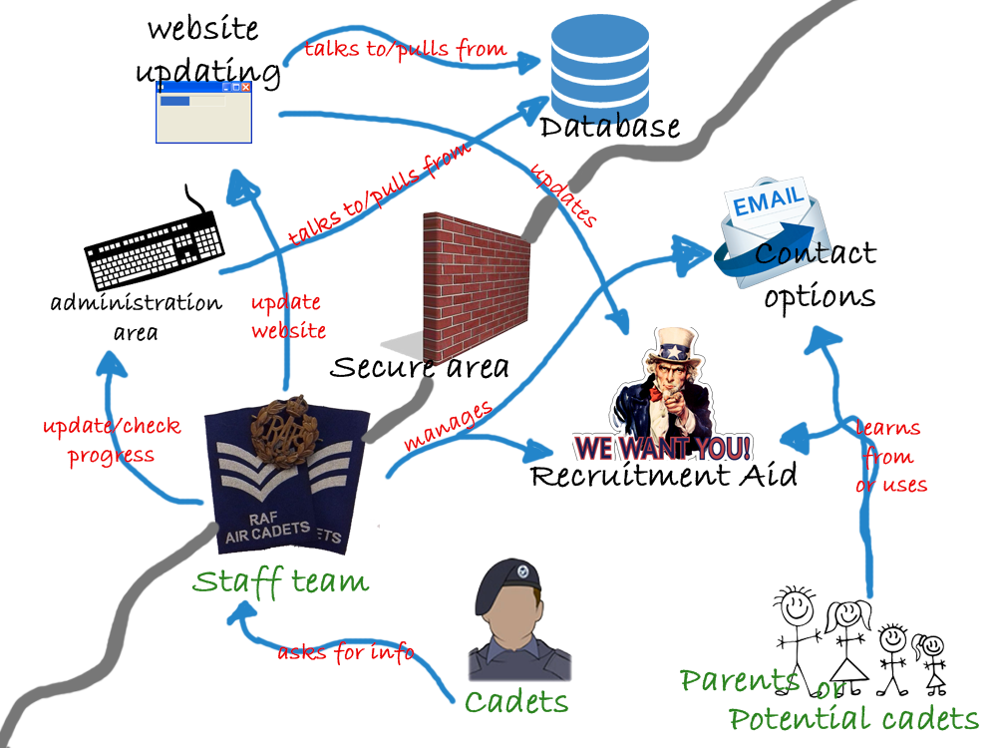

**Figure 1: Rich picture diagram of the key stakeholders**

Figure 1 above is a rich picture representation of the key features on the website. The persons in green are the typical users, which will be mentioned in more depth in the next section. The black areas are the parts and functions of the website that are planned to be created and used. The blue arrows with red writing are who is going to use what function of the site and what they may do.

# Typical Users

**User #1 (Typical Parent/Prospective Recruit)**

Julie is a 39 year old parent with a child aged 12. Julie herself is an average person in regards to IT literacy and is able to navigate the web itself and send emails. She normally uses a laptop to access sites but will also use her phone to send both emails and go on websites to talk to people.

Julie will access the website through various forms of advertisement, whether word of mouth or Facebook advertisement campaigns. Once on the site itself she will browse it for information on her child being able to join the cadets and use the ‘contact us’ page.

**User #2 (Cadet)**

Johnny is a 14 year old cadet whom attends the squadron. He is avid with technology and has high IT literacy skills. He primarily uses his phone to browse the internet and social media and is thus able to use the website effectively.

He will access the website through Facebook or knowledge of it from the squadron. Once on the site itself he may browse the site, but primarily will either be using the ‘contact us’ option or by using a ‘leave of absence’ form.

**User #3 (Member of Staff)**

Sara is a 23 year old member of staff who attends the squadron. She has basic IT literacy skills and primarily uses her phone, though for cadets uses one of the laptops available there.

She will access the site through knowledge of the link to access it. Once on the site itself she will be using the administration area to respond to messages and update the cadets’ progress.

**User #4 (Member of Staff – Admin)**

Scott is a 27 year old member of staff who attends the squadron. He has full IT literacy skills and uses all forms of devices to access things. He has an intimate knowledge of computing and website creation. He primarily uses a laptop.

He will access the site through knowledge of the web link to access it. Once on the site itself he will be using the administration area to perform all the tasks available, such as responding to messages and updating cadet progress. He will also be the webmaster, performing website updates, upgrades and managing user accounts.

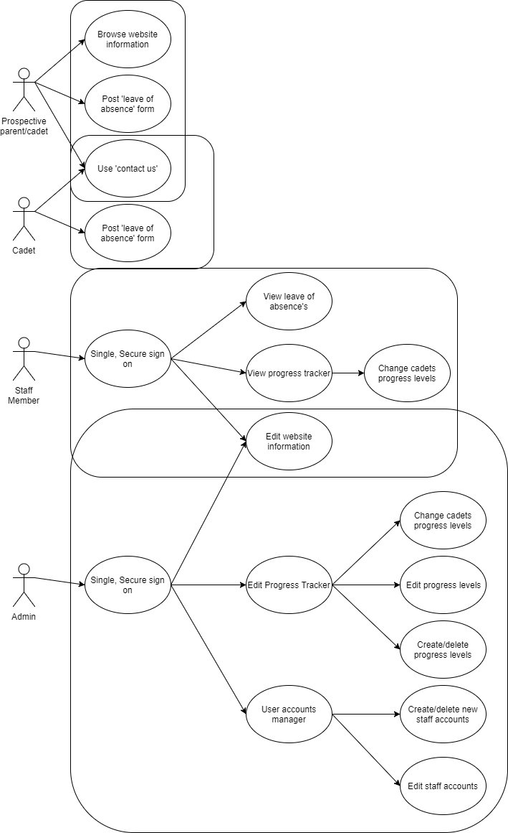

**Figure 2: Use case diagram for the site**

# Use Cases

Figure 2 to the right shows a use cases diagram for all 4 user types on the site. Below the functions are explained.

**Browse website information –** This is the standard function the user will perform on the site in browsing the site.

**Post ‘leave of absence’ form –** This is a simple form to fill out to log not attending the squadron on a night. It will include a name, date and reason on the submission form.

**Use ‘contact us’ –** This is another form that can be filled out to send an email or message to the staff at the squadron.

**Single, Secure sign on –** A simple login system using a secure library or token such as google login to ensure it is at its most secure. This will ensure that only certain persons can access the secure area.

**View leave of absence’s –** This allows the user to view theposted absences and deal with them appropriately. This is a simple thing to do yet is incredibly important for tracking attendance.

**View progress tracker -** This allows the user to view the main area of the administration section. It allows users to see the progress cadets have achieved in their time at the squadron.

**Change cadets progress levels –** This allows the user to modify the levels of progress the cadets have achieved, such as giving them higher levels or modifying dates, for example.

**Edit website information –** A WYSIWYG editor (providing the appropriate framework is available) to edit the standard pages of the website to ensure content is always up to date.

**Edit progress tracker –** A simple administration page to provide selection of features relating to the title.

**Edit progress levels –** Edit information on the progress levels itself such as the level, the name and suchlike.

**Create/delete progress levels –** Allows the user to create new progress levels or delete existing ones.

**User accounts manager –** An administration menu page in regards to editing accounts for the administration area itself.

**Create/delete staff accounts –** The ability to create new accounts or delete existing ones.

**Edit staff accounts –** Allows the user to edit the current accounts, such as change the associated email or force a password reset.

# Related Material

Due to the makeup of the site, there are few comparisons that can be made to the site as a whole. The administration back-end area is one that cannot be compared as it is specific for that unit and there are none (to my own knowledge) of others available to compare. The front-end site itself can be. The majority of these sites are very similar, with the only differences being a few different pages and systems used. Owing to the similarity of these sites, I will do one singular comparison highlighting key points to draw from the sites shown.

***All sites accessed at 1430 on 11/02/18.***

Site 1 - <http://162atc.co.uk/>

This is a wordpress site with standard features expected, including a contact us area and leave of absence form.

Site 2 - <https://www.184aircadets.org/>

Another seeming wordpress site, it holds standard features expected including contact us and a leave of absence form; however this is locked behind user accounts and a login system.

Site 3 - <http://561sqn.wixsite.com/home>

This is the current site of 561 squadron, the squadron I am creating a website for. It is created using wix, a website builder and holds very few extra features apart from information.

As can be seen from the above sites, there is little differences in most websites in the air cadets. These are the 3 I have looked at in detail, however there are more sites that I have glanced at that are all fairly similar. They all hold standard information areas and at least a contact us area. Leave of absence forms vary between squadrons and around half hold them. Taking from this is to make a clean, responsive site as much as possible that is easy to navigate and pleasing on the eye aesthetically.